



**Course title:** Operating Systems.

**Assignment on:** Bankers algorithms.

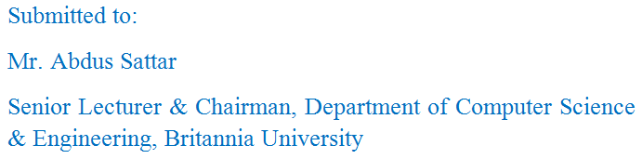

Date of Submission: 04-04-2016

Submitted by:

